**Walchand College Of Engineering, Sangli**

**Department of Computer Science and Engineering**

**Subject: C&NS Lab**

**Batch: B4**

**Name: Gayatri Sopan Gade PRN:2020BTECS00210**

**Assignment 8**

**Title:**

Implementation of Euclidean and Extended Euclidean Algorithm

**Implementation of Euclidean Algorithm**

**Code:**

#include<bits/stdc++.h>

using namespace std;

typedef long long int ll;

// function to find gcd of two integer numbers

ll gcd(ll a, ll b)

{

if (!a)

return b;

return gcd(b % a, a);

}

ll reduceB(ll a, char b[])

{

// Initialize result

ll mod = 0;

// calculating mod of b with a to make

// b like 0 <= b < a

for (int i = 0; i < strlen(b); i++)

mod = (mod * 10 + b[i] - '0') % a;

return mod; // return modulo

}

ll gcdLarge(ll a, char b[])

{

// Reduce 'b' (second number) after modulo with a

ll num = reduceB(a, b);

// gcd of two numbers

return gcd(a, num);

}

int main()

{

// first number which is integer

ll a = 1221;

char b[] = "1234567891011121314151617181920212223242526272829";

cout<<"Enter a Smaller Number: ";

cin>>a;

cout<<"Enter a Large Number: ";

cin>>b;

cout<<"\nThe GCD of Given Number is: ";

if (a == 0)

cout << b << endl;

else

cout << gcdLarge(a, b) << endl;

return 0;

**Output:**

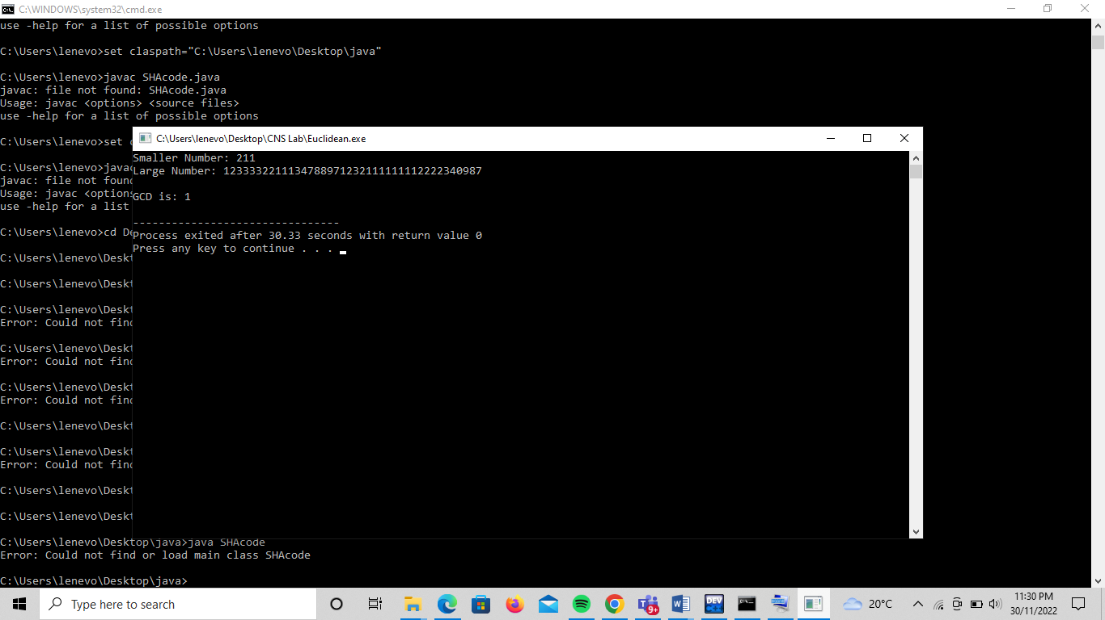

**Implementation of Extended Euclidean Algorithm**

**Code:**

#include<bits/stdc++.h>

typedef long long LL;

void extended_Euclidean_algorithm(LL a, LL b, LL &u, LL &v, LL &w, LL &x, LL &y, LL &z){

/* Initialization */

// 1. equation

u = 1; v = 0; w = a;

// 2. equation

x = 0; y = 1; z = b;

if( w < z ){ // we change the equations' order

std::swap( u, x );

std::swap( v, y );

std::swap( w, z );

}

LL q;

while( z != 0 ){

q = w / z;

// (1. equation) - q * (2. equation)

u -= q*x;

v -= q*y;

w -= q*z;

// we change the equations' order

std::swap( u, x );

std::swap( v, y );

std::swap( w, z );

}

}

int main(){

LL a, b, u, v, w, x, y, z;

// --------------------------

printf( "Data input\n" );

printf( "a = " );

scanf( "%lld", &a );

printf( "b = " );

scanf( "%lld", &b );

// --------------------------

extended_Euclidean_algorithm(a, b, u, v, w, x, y, z);

// --------------------------

printf( "\nResults:\n" );

printf( "1. equation: (%lld)*(%lld) + (%lld)*(%lld) = %lld\n", a, u, b, v, w );

printf( "2. equation: (%lld)*(%lld) + (%lld)*(%lld) = %lld\n", a, x, b, y, z );

// --------------------------

return 0;

}

**Output:**

